**Azure devops:**

* The merging of the devlopment team an operation team is Devops.
* Devops remove noise from the team.
* Now a days also most of the company working with team like manager ,scrum master , team lead , dev, QA ,etc because they can’t find all this feature in dev and it is costly also.
* 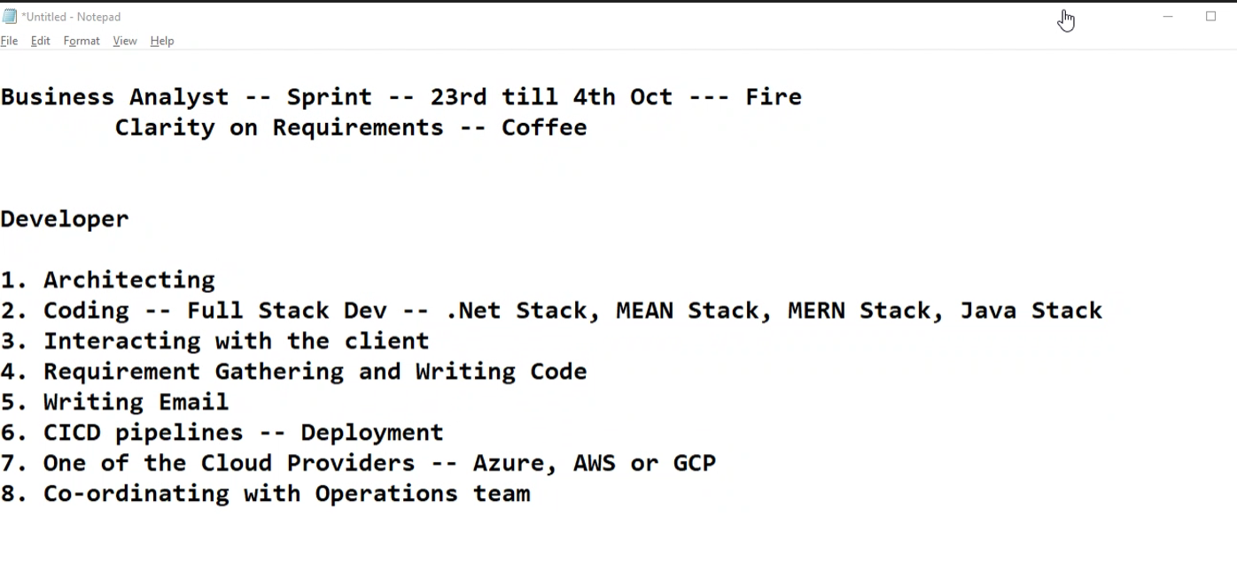
* Agile workItems:
  1. Epic(more than 2 sprints(2, 3, 4 weeks))
  2. Feature(Breakdown by team lead)
  3. User story(breakdown by senior Engg)
  4. Task(breakdown by software engg)

## Example (Amazon)—

* Epic-(customer service is epic for this)
* 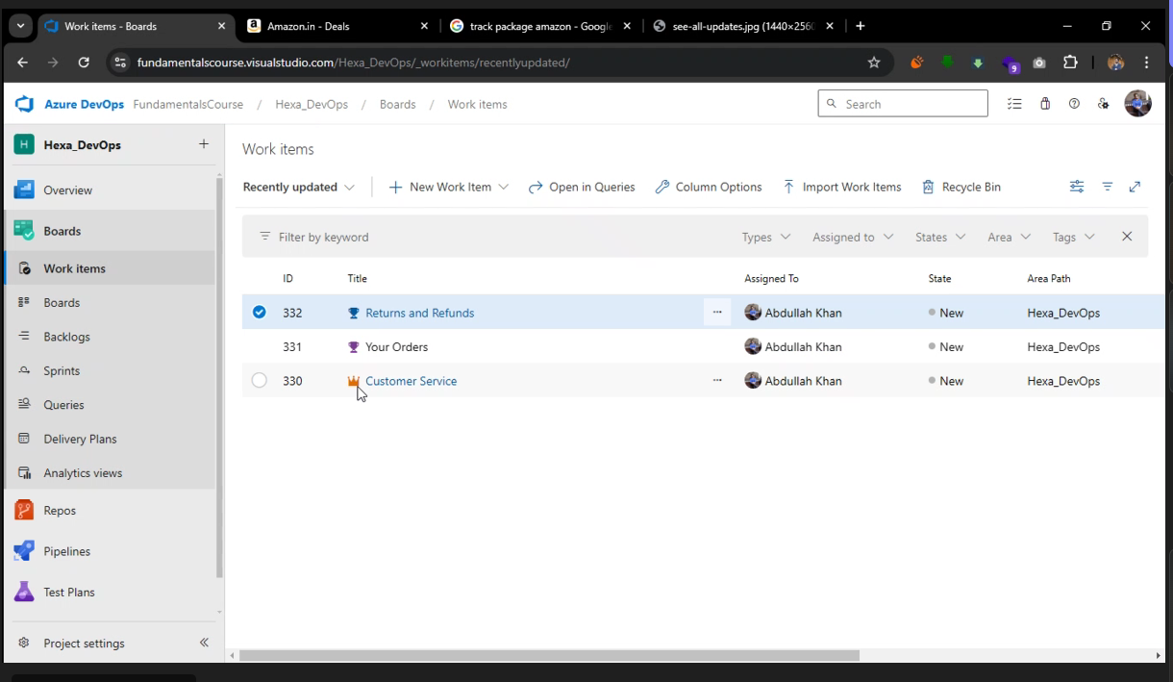
* Features
  1. Your orders
  2. Return and refunds
  3. Manage Address
  4. Manage prime

#Creating feature in azure devops

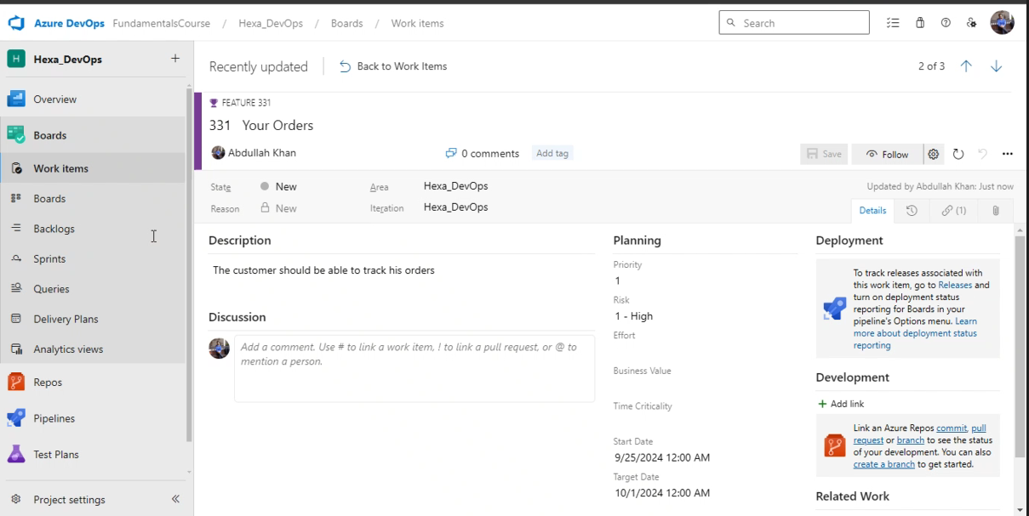

* 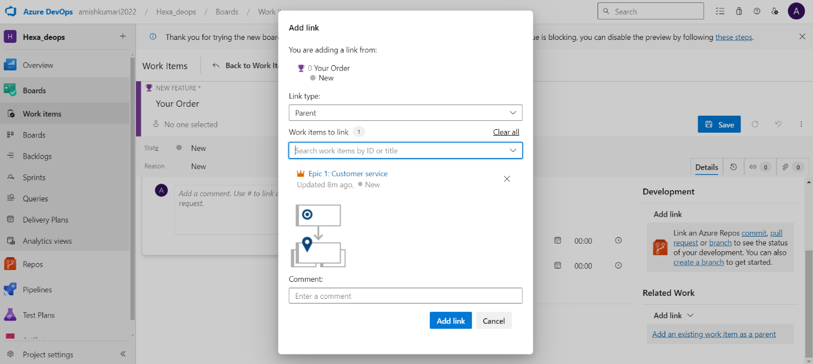
* 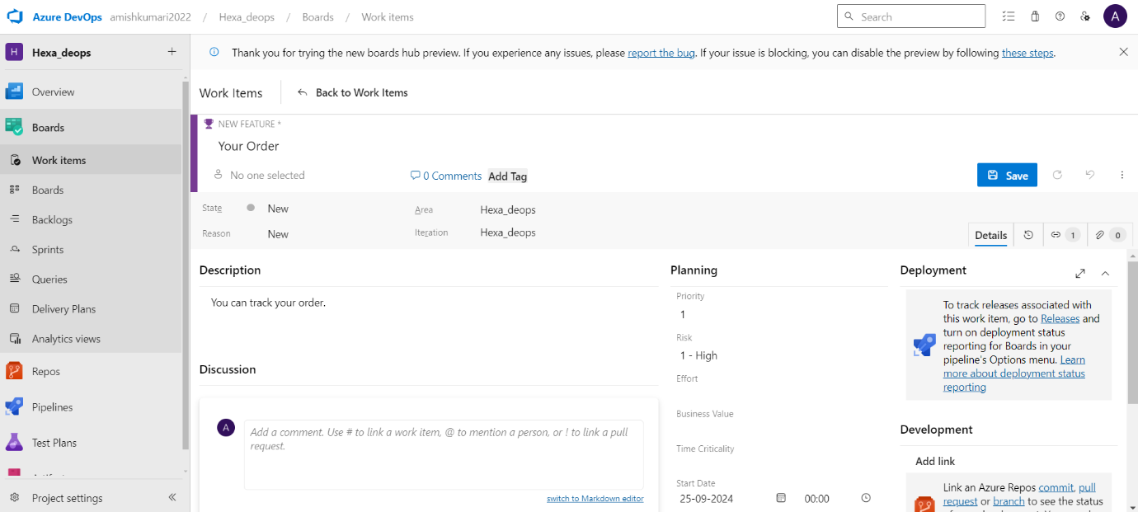
* All features created
* 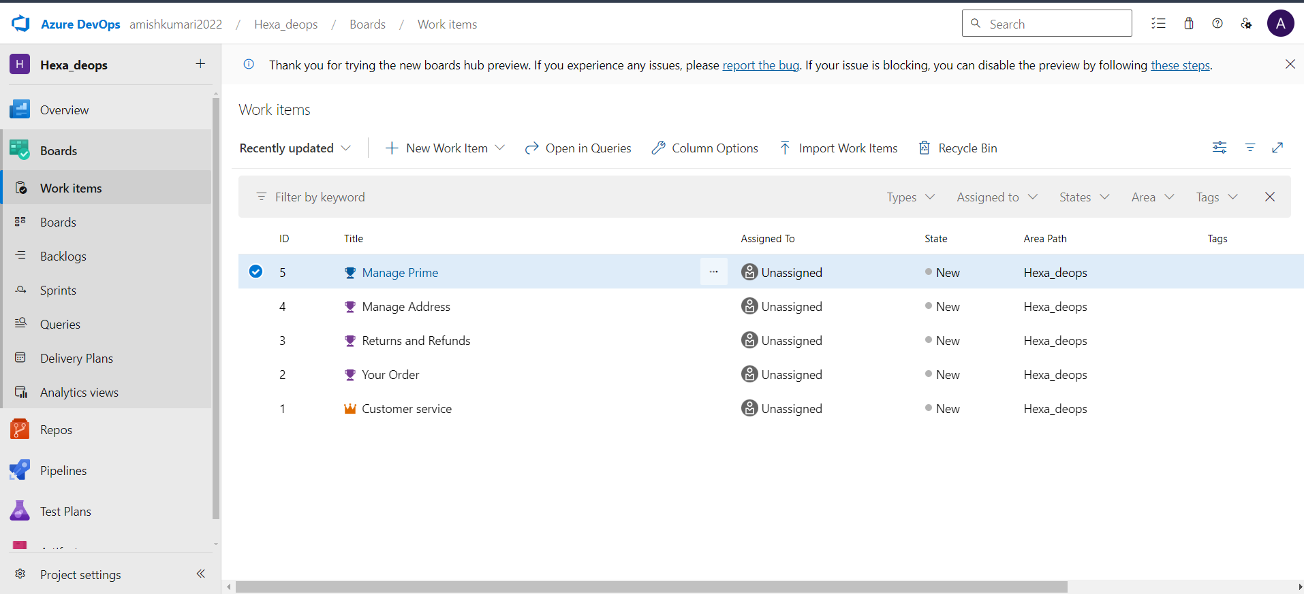
* User stories-
  + Your orders
    - Track order
    - Edit or cancel
  + Return and refund

1. Return and exchange

# creating user stories in azure devops

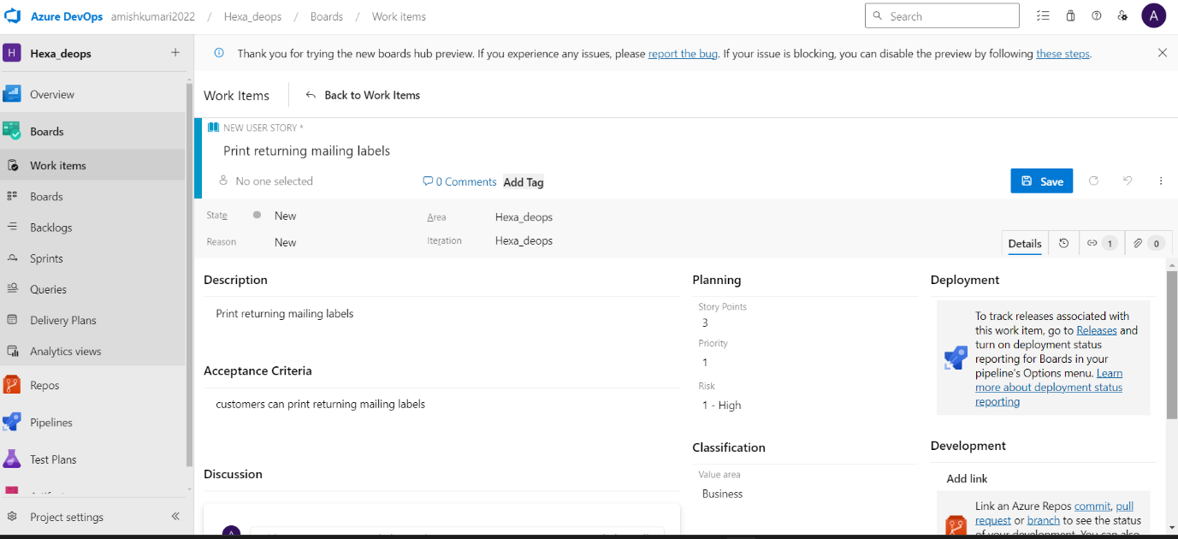

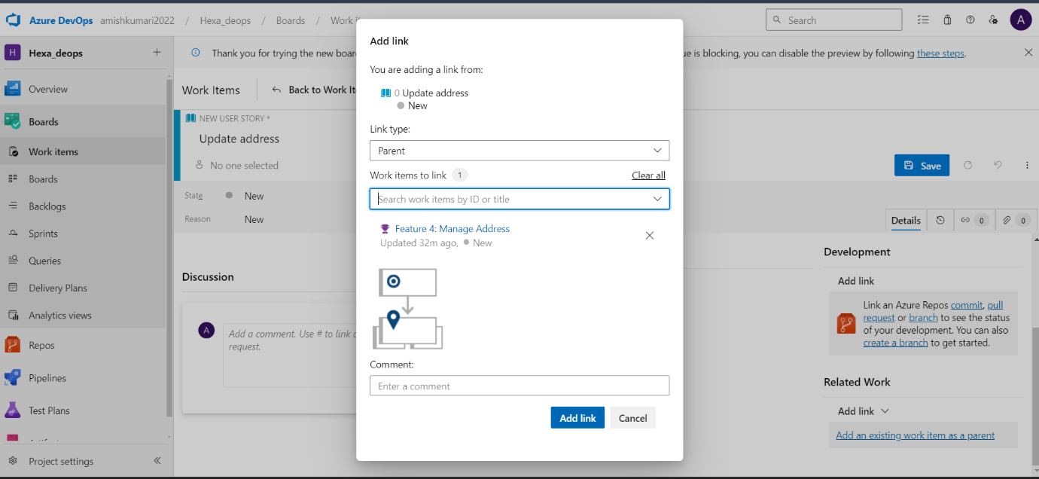

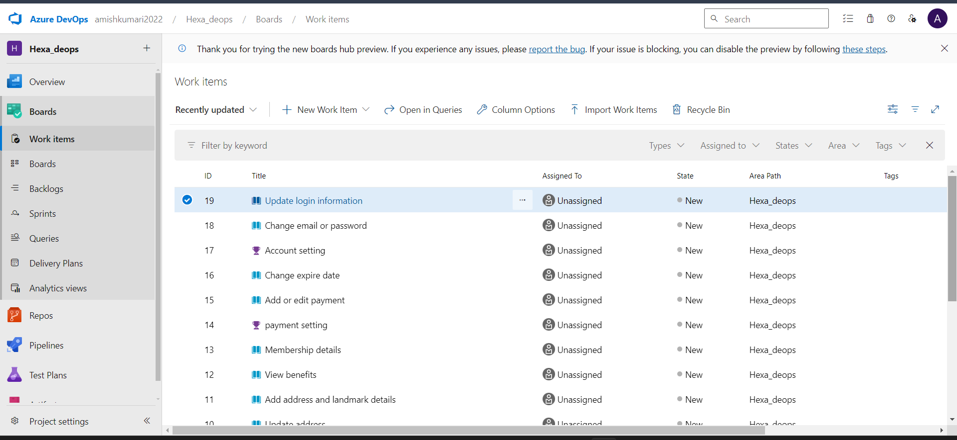

* Task(common for each of them)
  + Tark package
    - Build the user interface—8 hrs
    - Build the API layer—5 hrs
    - Build the database layer—6hrs

# Creating task in azure devops

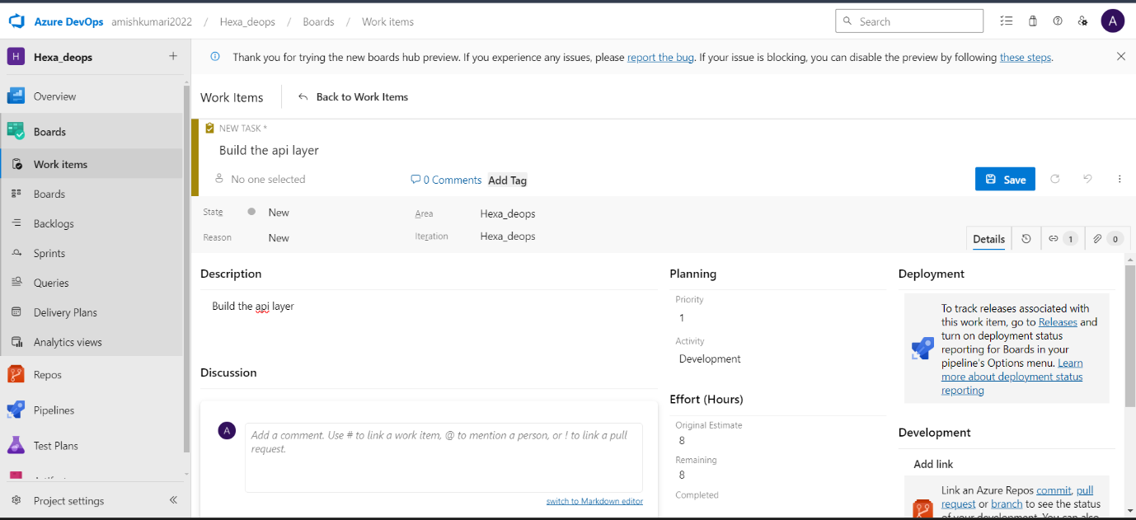

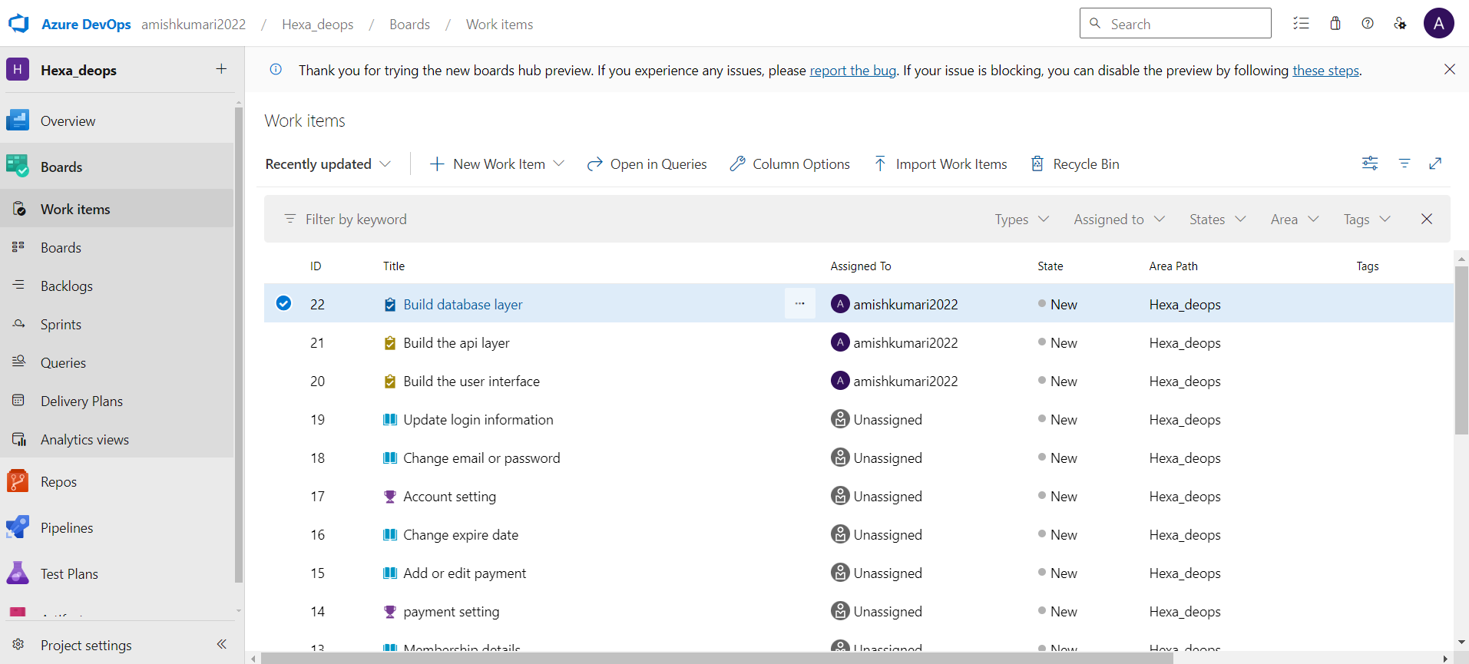

# Identify the all agile workitems in this :



# Answer:

*EPIC -- Amazon Payment

*Feature -- Using Amazon Pay

-- Using Paypal

-- Using Credit Card/Debit Card

*User Stories -- For Amazon Pay -- Connect With Users Amazon Pay Account

@ For PayPal -- Connect With Paypal

@ For Credit/Debit Card -- Connect with Bank's Portals

* Tasks -- for Connect with Users Amazon Pay Account –

1. Build UI

2. Build API to Amazon Pay

3. Build DB layer to update DB

for Connect with Paypal --

1. Build UI

2. Connect With Paypal's API interface

3. Build DB layer to update DB

for Connect with Bank's Portal --

1. Build UI

2. Connect with Bank's servers by building API

3. Build DB layer to update DB